**Name: Vijay Vishnu p b**

**Roll No:49**

**Batch:b**

**Date:24-03-22**

**NETWORKING & SYSTEM ADMINISTRATION LAB**

**Experiment No.: 3**

**Aim**

Familiarization of the linux commands.

**Procedure**

**1.pwd**

This command is used to display the location of the current workingdirectory.

Syntax :- $ pwd

Output :-

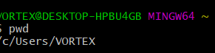

**2.mkdir**

This command is used to create a new directory under any directory.

Syntax :- $ mkdir <directory name>

Output :-

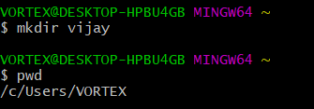

**3.ls**

This command is used to display a list of content of directory. Syntax :- $ ls

Output :-

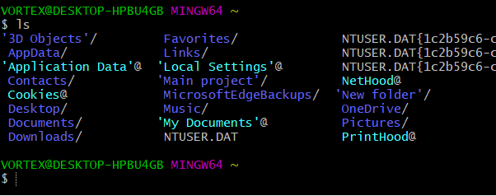

**4.man**

This command is used to display the user manual of any command that we can run on the terminal.

Syntax :- $ man <command name> Output :-



**5.ls –l**

This command is used to shows file or directory, size, modified date and time, file or folder name and owner of the file, and its permission.

Syntax :-$ ls–l

Output:-

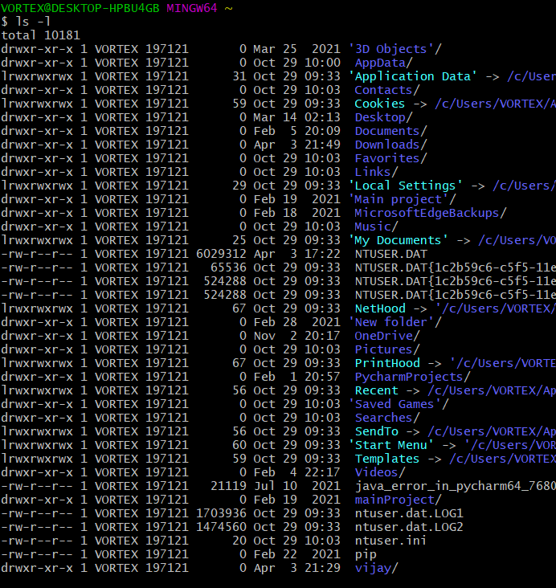

**6.ls-r**

This command is used to display files and directories in reverse order.

Syntax :-$ ls–r Output :-

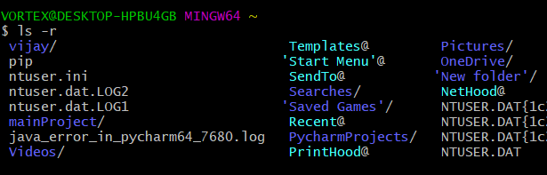

**7.ls-a**

This command is used to list all files including hidden files. Syntax :- $ls –a

Output :-

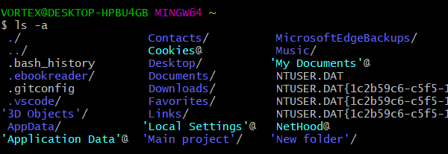

**8.ls-al**

display all files and subdirectories in the current directory, including hidden “.” And “..” etc. details.

Syntax :- $ ls -al

Output :-

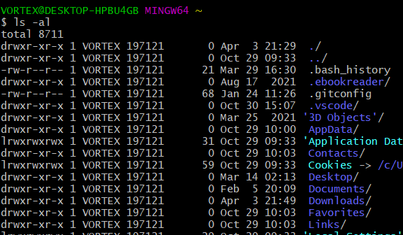

**9.ls –t**

This command is used to display files in the last modified order. Syntax :- $ ls –t

Output :-

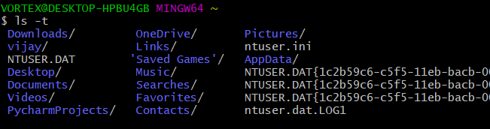

**10.cd**

This command is used to move to the parent directory of current directory, or the directory one level up from the current directory.

Syntax :- $ cd .. Output :-



**11.cd ..**

This command is used to move to the parent directory of current directory, or the directory one level up from the current directory.

Syntax :-$ cd ..

Output :-



**12.cd –**

This command is used to switch back to previous directory we were working earlier.

Syntax :- $ cd – Output :-

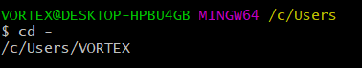

**13.cat > filename**

This command is used to create a file and add contents to that file. Syntax :- $ cat > filename.txt

Output :-

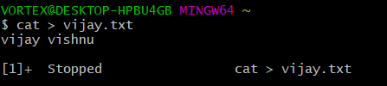

**14. cat >>filename**

This command is used to add contents to an existing file. Syntax :- $ cat >> filename.txt

Output :-

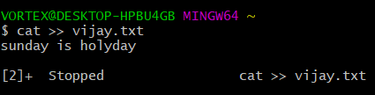**15.cat filename**

This command is used to view the contents in the file. Syntax :- $ cat filename.txt

Output :-

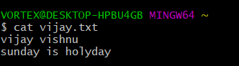

**16.cat filename1>filename2**

This command is used to copy the content from one file to another file. Syntax :- $ cat filename1 > filename2

Output :-

